
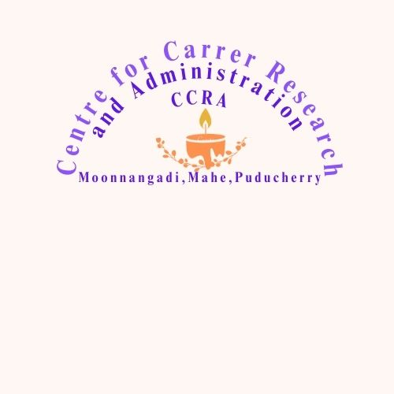

HALL TICKET (2022 Admission)
Name of Course : Certificate Course in Disabilities and Geriatric Care-CDGC
Name of the Examination : Part I- Theory | Affix  Paste Passport  Size Photo
Register Number : SDGC | Affix  Paste Passport  Size Photo
Name of Candidate : | Affix  Paste Passport  Size Photo
Year of Course : 2022-23 | Affix  Paste Passport  Size Photo
Date of Examination : | Affix  Paste Passport  Size Photo
Examination Centre : SABHA, Moonnangadi, Mahe
Signature of Candidate :
PART II- SOCIAL LAB
Date of Examination :
Examination Centre : SABHA, Moonnangadi, Mahe
Signature of Candidate :
Name of Invigilator :
Signature of Invigilator :
www.sabhamahe.in sabhamahe@gmail.com 9447300389

Instruction for Students
Medium of Exam : English and Malayalam
Duration of Theory Exam : 2 Hrs
Mark for Theory Paper : 100
Duration of Social Lab Exam : 2 Hrs
Mark for Social Lab Exam : 100

Competent Examination Cell, CCRA

